**Lab 1: Basic Gate Operations**

**Question 1: Design the following logic functions using basic gates and test the output using truth table**

1. **Y = ABC + DE + F**

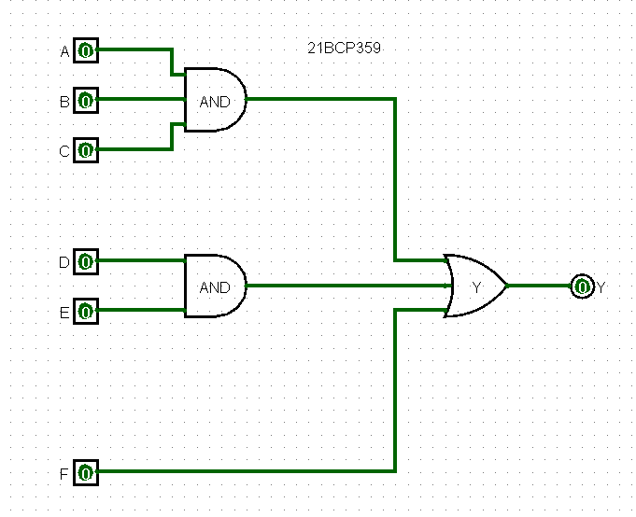

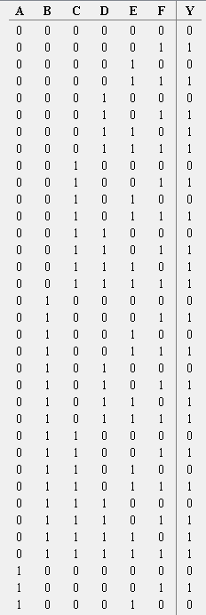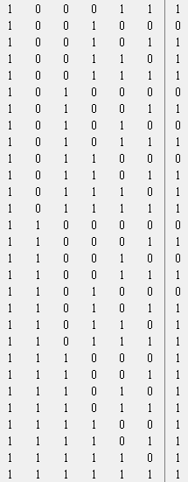

1. **Z = A’B’ + AB’ + A’B + AB**

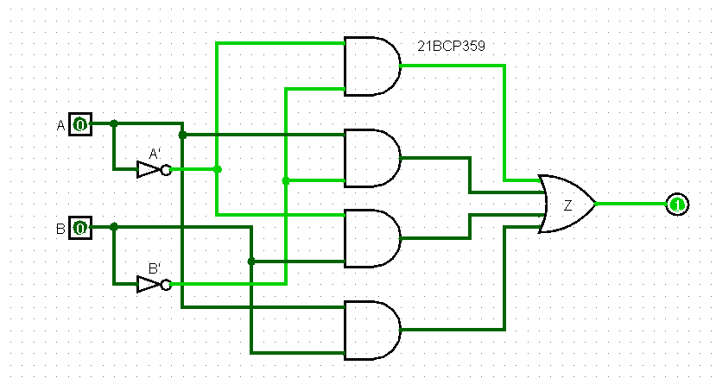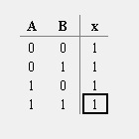

1. **K = (A’+B’) (A+B’) (A’+B) (A+B)**

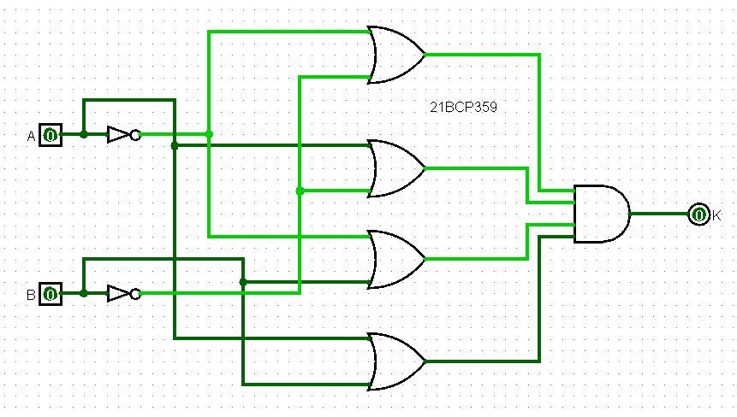 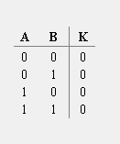

**Question 2: Design the verify the functionality using existing library of basic gates in Logisim.**

1. **Y = ((A+B).(C+D+E))’**

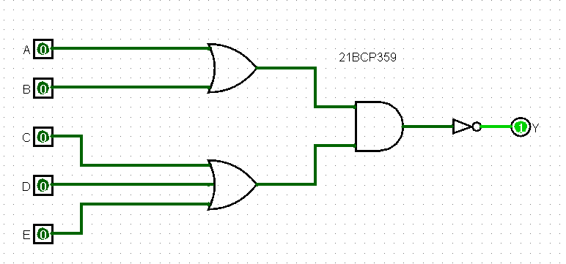

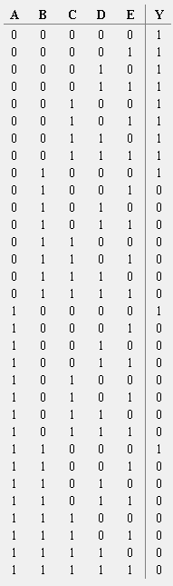

1. **F = ((A.B’)’+((A)’(B)’)’)’**

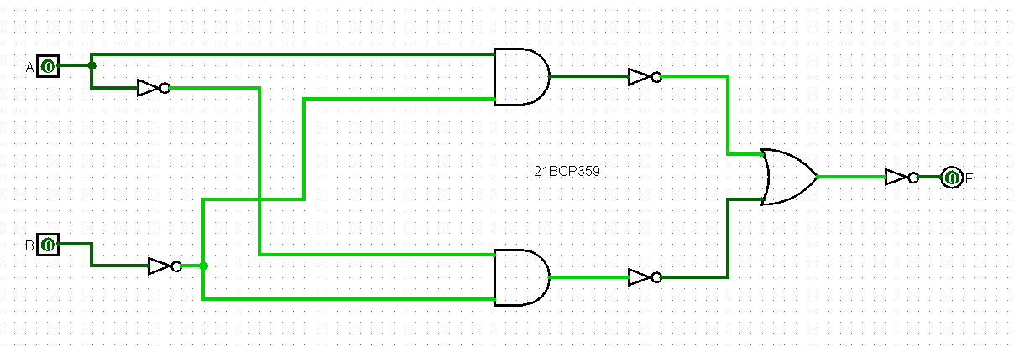

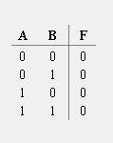

1. **K = (((A)’+B)’. ((A)’+(B)’)’)’**

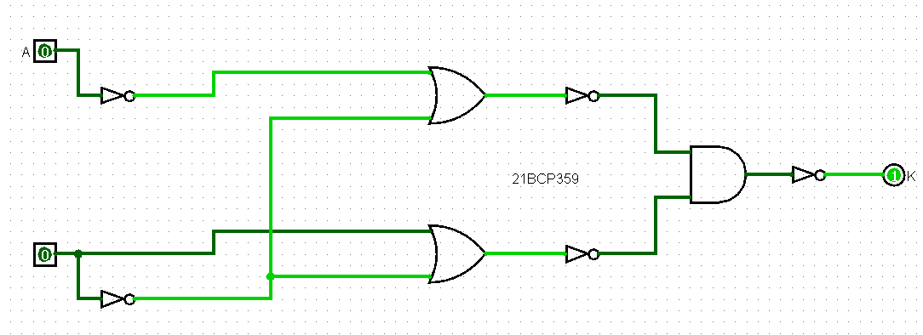

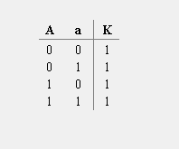

**Question 3: For each of the following problem statement, design a circuit, describe a Truth table and verify the outcome using Logisim**

1. **Implement the functionality of XOR gate using only NAND gates.**

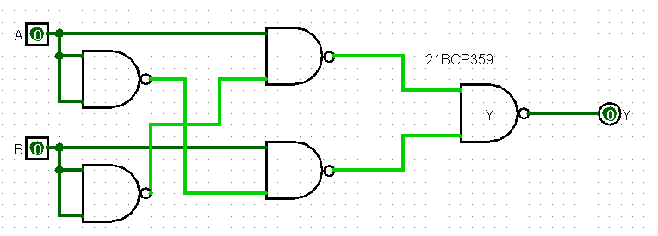

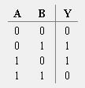

1. **Implement the functionality of XNOR gate using only NOR gates.**

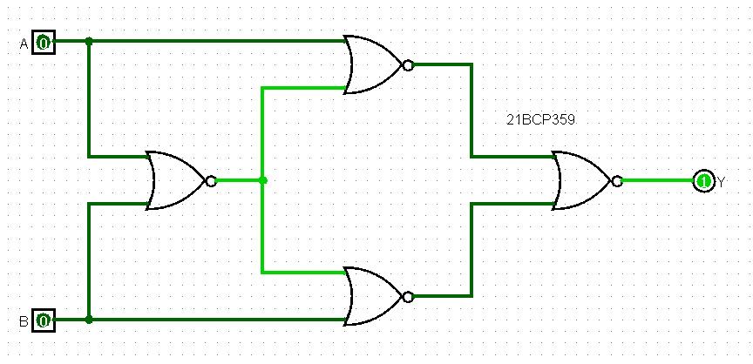

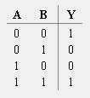

1. **Implement the functionality of AND gate using only NAND gates.**

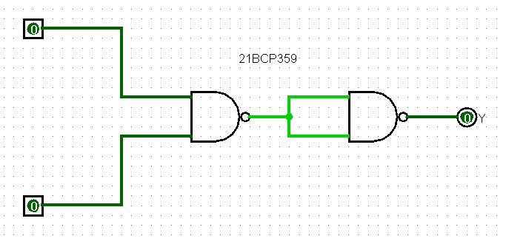

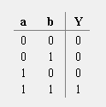

1. **Implement the functionality of OR gate using only NOR gates.**

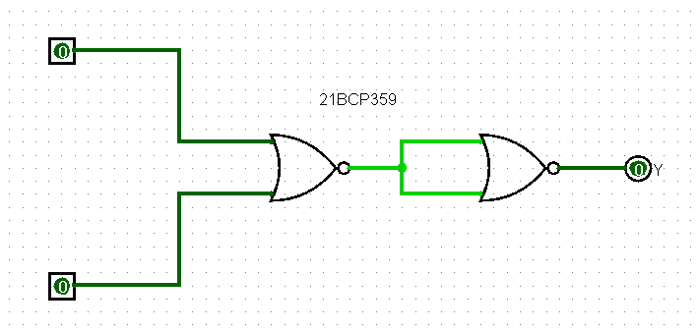

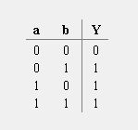

1. **Implement the functionality of NOT gate using only NAND gate.**

